POLYTECHNIC UNIVERSITY OF THE PHILIPPINES

COLLEGE OF COMPUTER AND INFORMATION SCIENCES

STA. MESA, MANILA

Optical Clinic Management System

Bongalos, Robert Julius G.

Amac, Pamela Amor A.

De Guzman, Naomi

Felix, Maria Antoinette P.

Gallardo, Joseph Jem P.

Lopez, Joselle P.

Nejal, Faye Bernadette

BSIT 3-3

Prof. Melvin Roxas

March 2017

**TABLE OF CONTENTS**

Chapter I – Project definition1

1. Introduction1
2. Project Case 2

2.1 Objectives2

2.2 Scope and Limitations2

1. Methods Used in the Project 4

3.1 Gathering Tools Used 4

3.2 Engineering Paradigm 4

1. Project Organizational Structure 4
2. Project Schedule 5

5.1 Pert Chart 6

5.2 Timetable of Activities 7

1. Problems Encountered 9
2. Conclusions and Recommendations9

CHAPTER II – PROJECT DESIGN11

1. System Screenshots11

**CHAPTER I: PROJECT DEFINITION**

1. **Introduction**

The *CO Clinic* or *Coonie’s Optical Clinic* started operating after Dra. Connie Galgana graduated in Centro Escolar University. However, the clinic was not fully registered by that time, so it technically started in 2014. The clinic before it was fully accredited moved from one place to another. Its current system is dependent on the traditional way of processing information such as using of spreadsheets; some are still on papers. The clinic’s way of gathering data from patient is also being done manually through forms. Aside from these, there are other clinic branches that are also being managed by the owner herself. The business is a sole proprietorship. Ms. Galgana and her husband were the only ones who run the company together with the other clinics.

The **Optical Clinic** provides services for eye care. These services in particular are eye refraction, contact lenses, solutions, and glasses.

The eye care services are operated in manual procedures; this includes the sales and inventory. Patients can set appointment through calls but they usually accept walk-ins. New patients are being asked if they have old glasses to examine. The doctor only uses her phone to remind her on appointments. Records of patients and their payment, sales, and inventory are stored in Microsoft Excel files and index cards. Aside from this, they also keep track of patient history records with bulky paper forms on hand. These forms are claim stubs, patient records, Rx, job order, and summary sheets.

The proposed project will address the following problems encountered by the **optical clinic**:

* Manual operation of patient records, appointment scheduling, sales, and inventory
* Slow generation of sales reports and inefficient computing resources
* Processing of requests consume most of the customer’s time queue
* Scheduled appointments are not properly tracked
* Security of the files in the organization

**2. Project Case**

**2.1. Objectives**

The core reason for the establishment of computerizing its optical records and inventory management system is to put the doctor and clinic staff in a convenience and ease, because the old way of manually recording and managing of files and records which are is currently in use cause many problems to the doctor and patient. *Optical Management System* will surely indeed serve as a solution to these problems. The ophthalmologist and personnel would be able to do work efficiently and accurately with minimal errors without consuming more time. They would avoid redundancy of records and members of the staffs will be at ease in working on different transactions. The doctor who manages the inventory and distribution of supplies can now easily monitor their supplies and also easily to determine the expiry dates of different medicines. Also, staffs would be able to generate reports with accurate and necessary information prior to their standardized format of reports.

* To capture the business needs and requirements of optical clinic management system in handling and conducting records of the patients, payments and balances, inventory and sales, and scheduling of appointments including notifications.
* To avoid lengthy process of recording patients, to reduce bulky paper storage.
* To provide a quick and accurate way of operation and in order to ensure easy retrieval of records.
* To provide as an easier method for back-up transactions.
* To provide easier viewing of the reports.

**2.2.** **Scope and Limitation**

The study covers almost all of the operation on going in the clinic. Starting from the existing patient’s records, additional patient records, current and remaining balance, payments and payment history, calendar-type schedule of the optometrist and patient, booking of appointment on optometrist’s end and customer’s end, notifications and reminders for the patients, process returns, services, product tracking and adjustments.

All matters regarding employee records and payroll are not included in the system.

The following are the identified modules and sub-modules of the proposed system:

* **Admin’s Module**
* **Branches** - Contains records of the clinic branches. Admin can add, update and deactivate branches.
* **Optometrists** – Records of Optometrists, and which branch they are assigned to. The admin can add, update and delete optometrist records.
* **Employees** – List of all employees in the business other than the doctor. Here the admin can add employee record, update or delete them.
* **Product Types** – List of product types the business is selling.
* **Products** – Products which are available in the clinic. Details such as product model, brand and type are fields included.
* **Services** – Services available in the business such as eye refraction and repairs. Admin can add services, update details, or delete.
* **Doctor’s Module**
* **Appointments/ Schedule**–keeps track of all the appointed time and due dates of every meet-ups and appointments of the doctor with the patients
* **Patient's Record** – Overview of the patients’ record information, such as grade of the patient’s eye, name of the patient and their address.
* **Services** – List of services available in the clinic.
* **Sales and Inventory** – Records every transaction for each material purchased and every operation, including all the reports on monthly sales and annual sales.
* **Patient’s Module**
* **Notification** – this informs the doctor for every scheduled appointments and due dates for payments and orders.
* **Payments Schedule** – It is an overview of all the appointed checkups and due dates to purchase their orders, payments and balances.
* **Set Appointment** – This is where the patients will be able to set the times and dates according to their choice and availability.
* **Assistant/Employee’s Module**
* **Orders** – This contains list of products ordered identified per batch from suppliers and its quantity, date ordered and order status.
* **Inventory ­**– A list of all products on hand, including the product details such as serial code, price, available stock and expiration date.
* **Adjustments** – This functions as adding or subtracting on inventory for reasonable concerns like miscount, defects, etc.
* **Warranties ­**– List of warranties and their status. The assistant will be informed for active, replaced or inactive warranties.
* **Unclaimed** – A list of products availed by patient but is still unclaimed.
* **Expired Products** – Contains list of products which are out of date or expired.

1. **Methods Used in the Study**
   1. **Gathering Tools Used**

*Personal Interview.* The data were gathered through an interview where the team had a chance to analyze and study the agency’s processes, policies, procedures and also the tasks done by their employees.

* 1. **Engineering Paradigm**

*Agile Model.* There is an incremental approach in developing the system. The working software built is delivered after each iteration. The finalized system includes all of the features required by the client.

1. **Project Organizational Structure**

|  |  |  |
| --- | --- | --- |
| **FUNCTION** | **NAME** | **ROLE** |
| Leader, Main Programmer | Robert Julius G. Bongalos | Leads and gives instruction/ things to work by each member. Also holds the final decision and works front-end and back-end. |
| Programmer, Designer | Pamela Amor A. Amac | Helps in coding and designing the UI of the project |
| Documentation Writer | Naomi De Guzman | Works on documentation, and contact person to doctor |
| Project Manager, Programmer, Designer | Maria Antoinette P. Felix | Helps in coding and designing the UI and debugs code |
| Programmer, Quality Assurance | Joseph Jem P. Gallardo | Helps in coding and test the system. Assures that the system works properly. |
| Head Documentation Writer | Joselle Lopez | Works on the combined documentation, and holds every documentation that is done |
| Documentation Writer | Faye Bernadette Nejal | Helps in creating documentation. |

1. **Project Schedule**
   1. **PERT Chart**

Critical Path: A-B-C-E-F-G-H-I-L-M-N-P-Q-R-S-T

Time of Finish: 100 Days

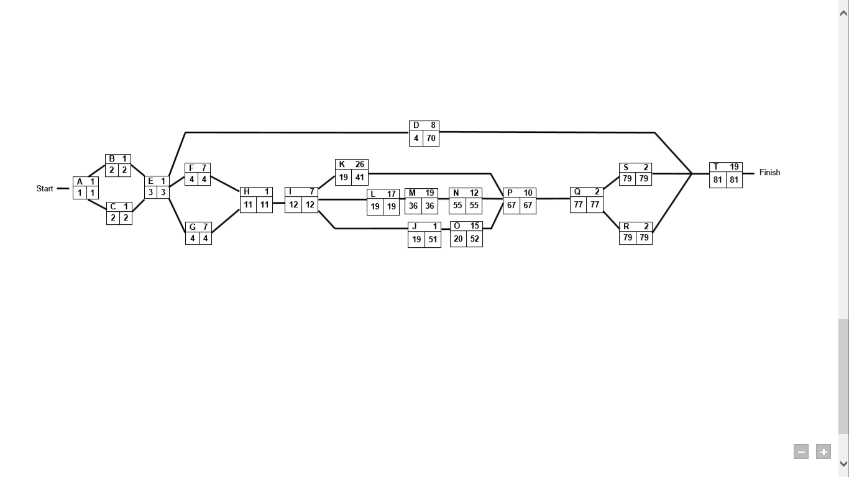

|  |  |  |  |  |
| --- | --- | --- | --- | --- |
| **ACTIVITY/TASKS** | **PRE-REQUISITE/S** | **EARLY START TIME** | **LATE START TIME** | **FLOAT** |
| 1. Create Questionnaires for Interview | - | 1 | 1 | 0 |
| 1. Construct Interview with the Client | A | 2 | 2 | 0 |
| 1. Collect Data and Forms | A | 2 | 2 | 0 |
| 1. Creating Chapter 1 and 2 | E | 4 | 70 | 66 |
| 1. Analyze and Create Workplan | B, C | 3 | 3 | 0 |
| 1. Create Prototype | E | 4 | 4 | 0 |
| 1. Design Schema | E | 4 | 4 | 0 |
| 1. Meet with the Client for Additional Functionalities | F, G | 11 | 11 | 0 |
| 1. Finalize UI and Database Design | H | 12 | 12 | 0 |
| 1. Create Repository | I | 19 | 51 | 32 |
| 1. Prioritize Working on the Maintenance | I | 19 | 41 | 22 |
| 1. Do Admin Module | I | 19 | 19 | 0 |
| 1. Do Doctor Module (including partial transactions | L | 36 | 36 | 0 |
| 1. Do Patient Module (including partial transactions) | M | 55 | 55 | 0 |
| 1. Do Secretary Module (including partial transactions) | N | 20 | 52 | 32 |
| 1. Finalize, Validation and Debugging of ALL Modules | K, O, J | 67 | 67 | 0 |
| 1. Viewing of Reports via Web | P | 77 | 77 | 0 |
| 1. Generate Printed Outputs | Q | 79 | 79 | 0 |
| 1. Finalize the System Software | Q | 79 | 79 | 0 |
| 1. Final Debugging and Validations of System | R,S | 81 | 81 | 0 |

* 1. **Timetable of Activities**

|  |  |  |  |
| --- | --- | --- | --- |
| **ACTIVITY** | **DATE STARTED** | **DATE FINISHED** | **NO. OF DAYS** |
| 1. Create Questionnaires for Interview | November 30, 2016 | November 30, 2016 | 1 |
| 1. Construct Interview with the Client | December 5, 2016 | December 5, 2016 | 1 |
| 1. Collect Data and Forms | December 5, 2016 | December 5, 2016 | 1 |
| 1. Creating Chapter 1 and 2 | December 8, 2016 | March 24, 2016 | 8 |
| 1. Analyze and Create Workplan | December 7, 2016 | December 7, 2016 | 1 |
| 1. Create Prototype | December 8, 2016 | December 14, 2016 | 7 |
| 1. Design Schema | December 8, 2016 | December 14, 2016 | 7 |
| 1. Meet with the Client for Additional Functionalities | January 6, 2017 | January 6,2017 | 1 |
| 1. Finalize UI and Database Design | January 7, 2017 | January 13, 2017 | 7 |
| 1. Create Repository | January 15, 2017 | January 16, 2017 | 1 |
| 1. Prioritize Working on the Maintenance | January 16, 2017 | February 10, 2017 | 26 |
| 1. Do Admin Module | January 16, 2017 | February 1, 2017 | 17 |
| 1. Do Doctor Module (including partial transactions | January 23, 2017 | February 10, 2017 | 19 |
| 1. Do Patient Module (including partial transactions) | January 30, 2017 | February 11, 2017 | 12 |
| 1. Do Secretary Module (including partial transactions) | February 1, 2017 | February 15, 2017 | 15 |
| 1. Finalize, Validation and Debugging of ALL Modules | February 16, 2017 | March 17, 2017 | 10 |
| 1. Viewing of Reports via Web | March 22, 2017 | March 23, 2017 | 2 |
| 1. Generate Printed Outputs | March 23, 2017 | March 24, 2017 | 2 |
| 1. Finalize the System Software | March 24, 2017 | March 25, 2017 | 2 |
| 1. Final Debugging and Validations of System | March 25, 2017 | March 25, 2017 | 1 |

1. **Problems Encountered**

|  |  |  |
| --- | --- | --- |
| **FUNCTION** | **NAME** | **ROLE** |
| Absenteeism rate and tardiness of the members were high | Antoinette Felix | Project Manager |
| Conflicting schedules were encountered since some of the team members are irregular students. | Antoinette Felix | Project Manager |
| Insufficient funds for documentation and other materials needed | All Members |  |
| Lack of communication among the members. | All Members |  |
| Some adjustments and modifications every after consultation | RJ Bongalos | Main Developer |
| Some business rules and processes are not standard | RJ Bongalos | Main Developer |

1. **Conclusions and Recommendations**

After studying the processes in the business, the team therefore concluded that the current system of the clinic must be improved. The core reason for the establishing its computerized optical records and inventory management system was to put the doctor and clinic staff in a convenience and ease. The paper-based system currently in use caused many problems to the doctor and patient. The few problems encountered by the manual system was that, first, the medical card record was easily exposed to unauthorized person. Next was having redundant information. This happens when sometimes a patient record was misplaced leading to inputting another record for the same patient. Data input errors especially in sales which leads to miscalculated capital, expenses and gross income. In addition to those mentioned, seeking for some records, even in doing transactions manually was time-consuming. Another dilemma of the business was that there were no fixed discounts in the products, causing the business to have loss of sales. There was also a problem in appointment scheduling of the current system. The clinic accepts appointment reservation via calls and texts but is not fully monitored by the optometrist because most of their patients are walk-ins. Patients who are advised to come back for follow-up checkups were also not tracked by the optometrist in charge.

With the list of problems occurring in their old way, the employees’ efficiency and effectiveness suffers. Optical Clinic Management System will surely be a solution to these problems. The ophthalmologist and personnel would be able to do work efficiently and accurately with minimal errors without consuming more time. They would avoid redundancy of records and members of the staffs will be at ease in working on different transactions. The doctor who manages the inventory and distribution of supplies can now easily monitor their supplies and also easily to determine the expiry dates of different medicines. Also, staffs would be able to generate reports with accurate and necessary information prior to their standardized format of reports.

After the analysis of all the operations in the optical clinic, the team recommends the following:

* Provide a computer-based system for maintaining records of the transactions in the company including the scheduling of appointments of the patients.
* Use of backup mediums such as external hard drives, for backups and storage of data.
* Having printable and up-to-date generated reports provided by the system.
* Utilization of computer for fast processing of transactions.
* To prevent issues in inventory distributions and lost supplies, there should be tracking of inventory supplies, transactions and distribution history which is included in the functions of the system.
* For additional security of confidential records there must be a log-in facility for staff and the administrator, which is also present in the system.
* Staffs of the clinic must be educated on how the system will operate and how it enhances their efforts.

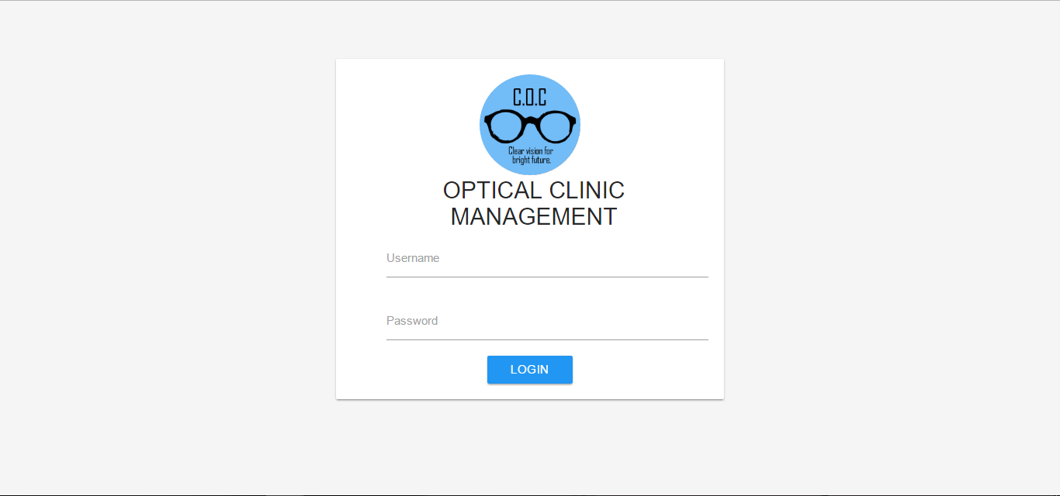**CHAPTER 2: Project Design**

**Figure 2.1 User Log In**

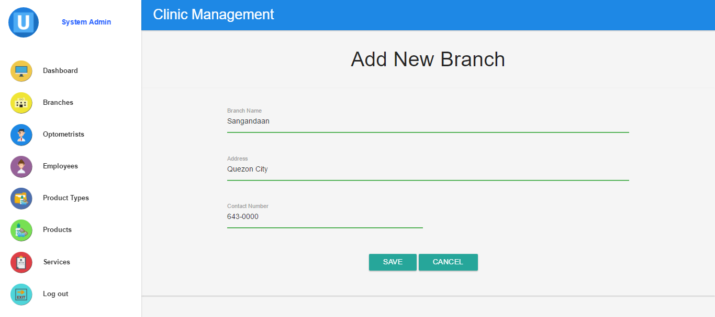**(**Log-in form for users. Through this form, the system can identify the user type: Admin, Optometrist, Employee and Patient**)**

**Figure 2.2 Admin - Add New Branch**

**(**Form for adding branches where optometrist can be assigned.)

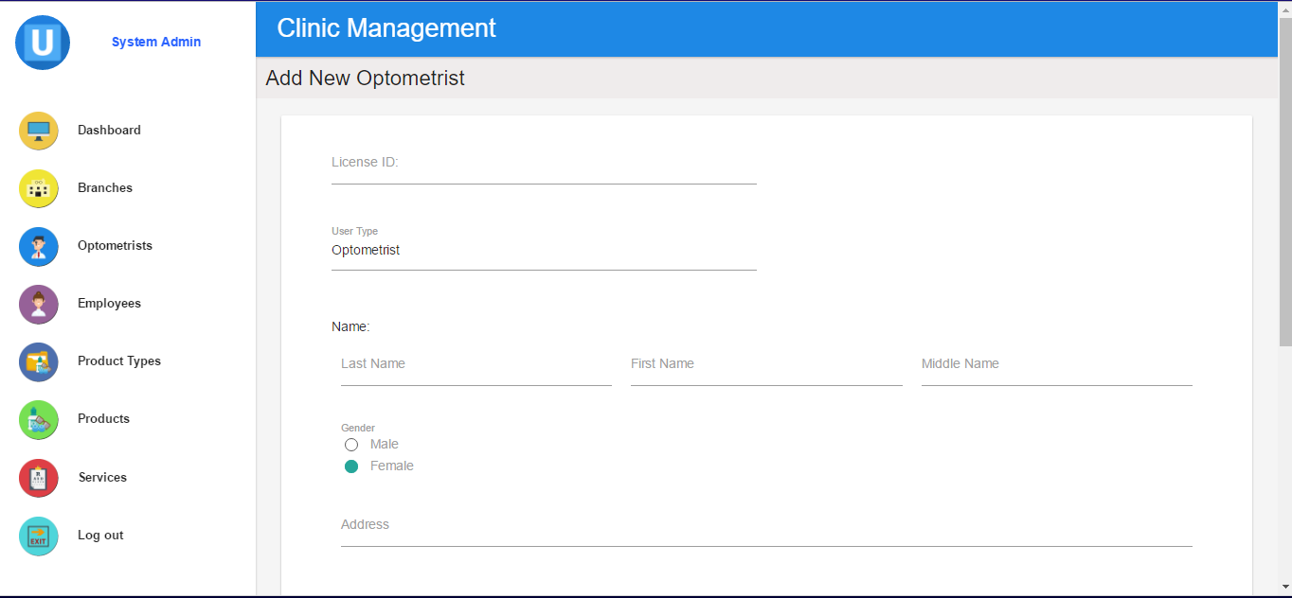

**Figure 2.3.1 Admin – Add Doctor Record Form**

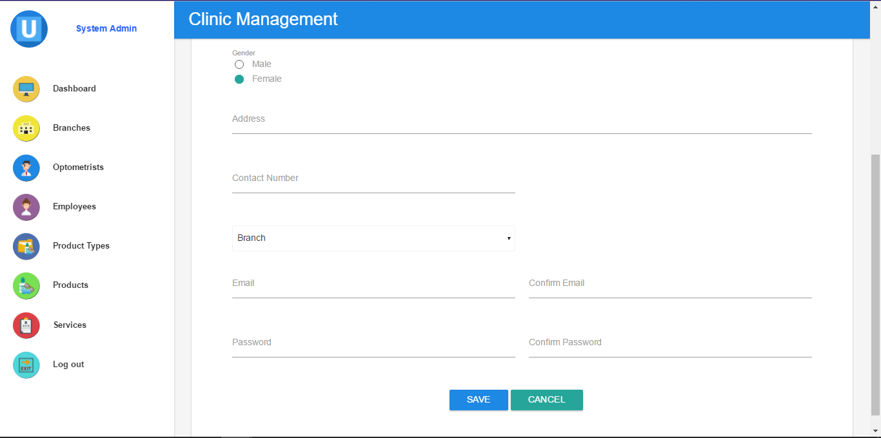**(**Form for adding new optometrist in specific clinic branch. Contains all necessary information of the optometrist)

**Figure 2.3.2 Admin – Add Doctor Record Form**

**(**Continuation of the form)

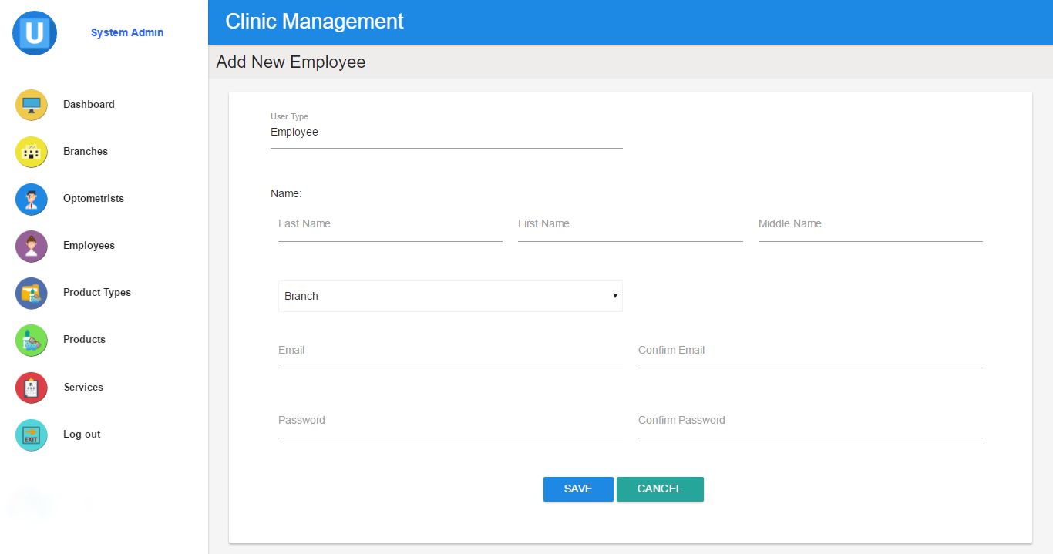

**2.4 Admin – Add New Employee Form**

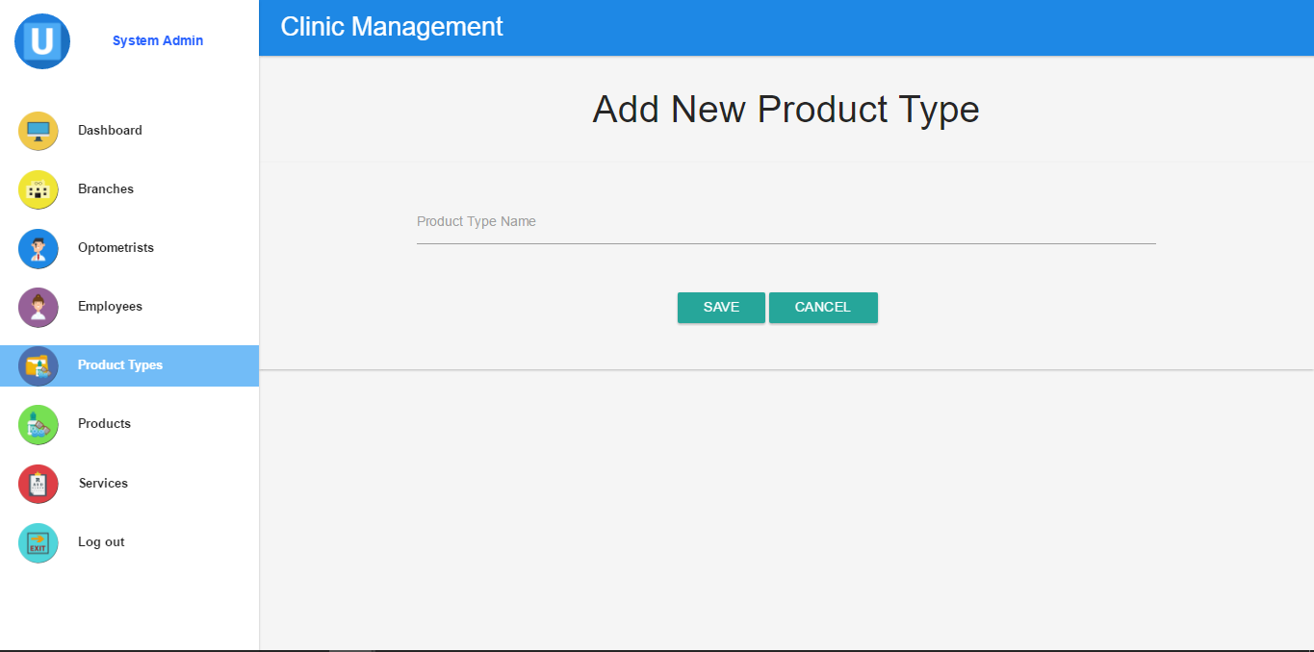**(**Form for adding new employee in specific clinic branch. Contains all necessary information of the employee. )

**Figure 2.5 Admin – Add New Product Type Form**

**(**Form for adding new product type in available in the clinic e.g. sunglasses**)**

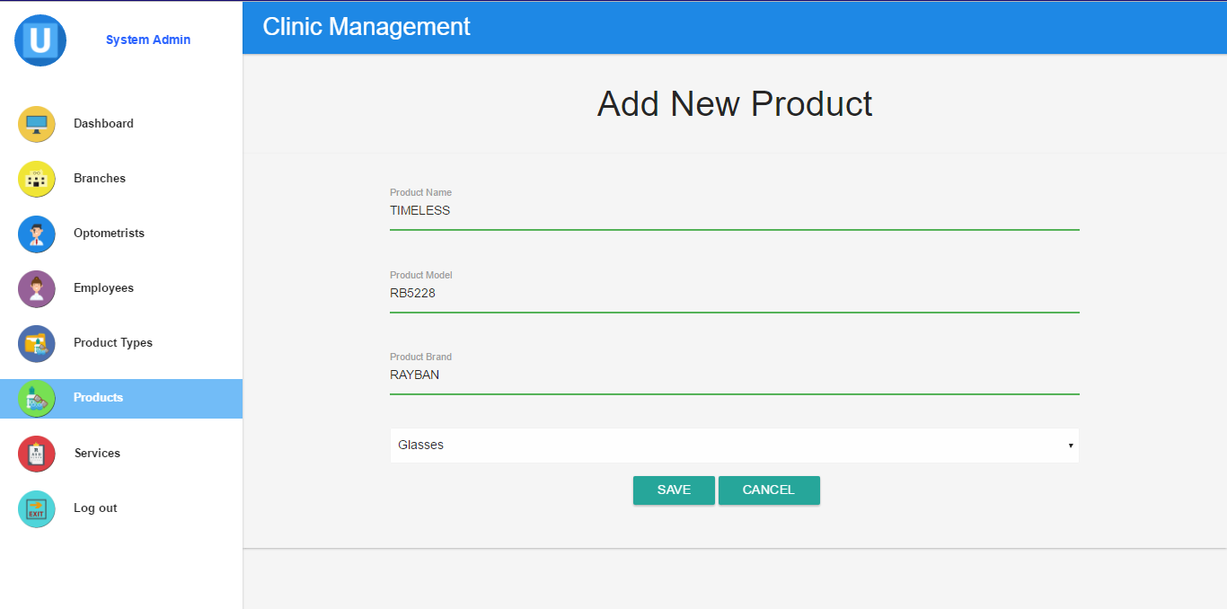

**Figure 2.6 Admin – Add New Product**

**(**Form used for adding new product of specific product type)

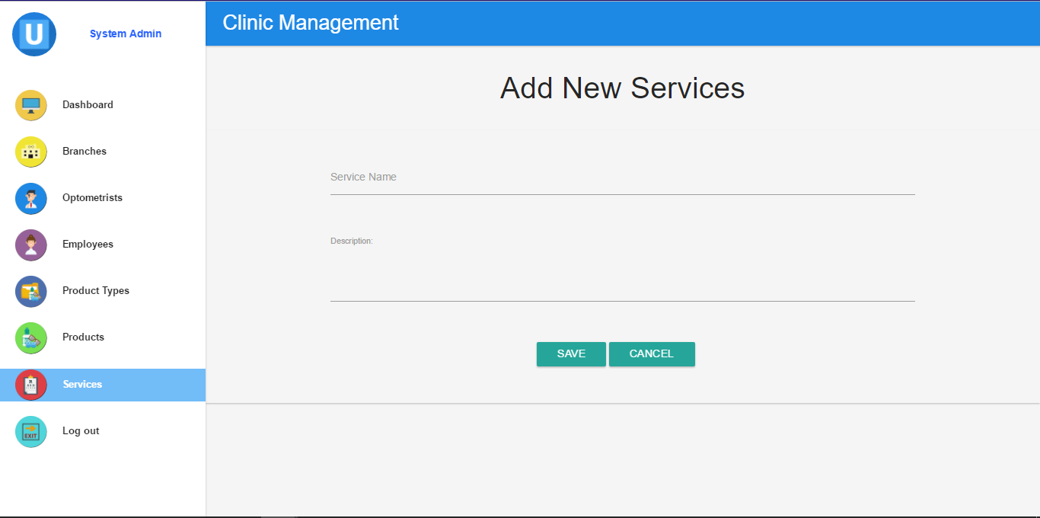

**Figure 2.7 – Admin – Add New Service**

**(**Form for adding new service to be offered in the clinic)

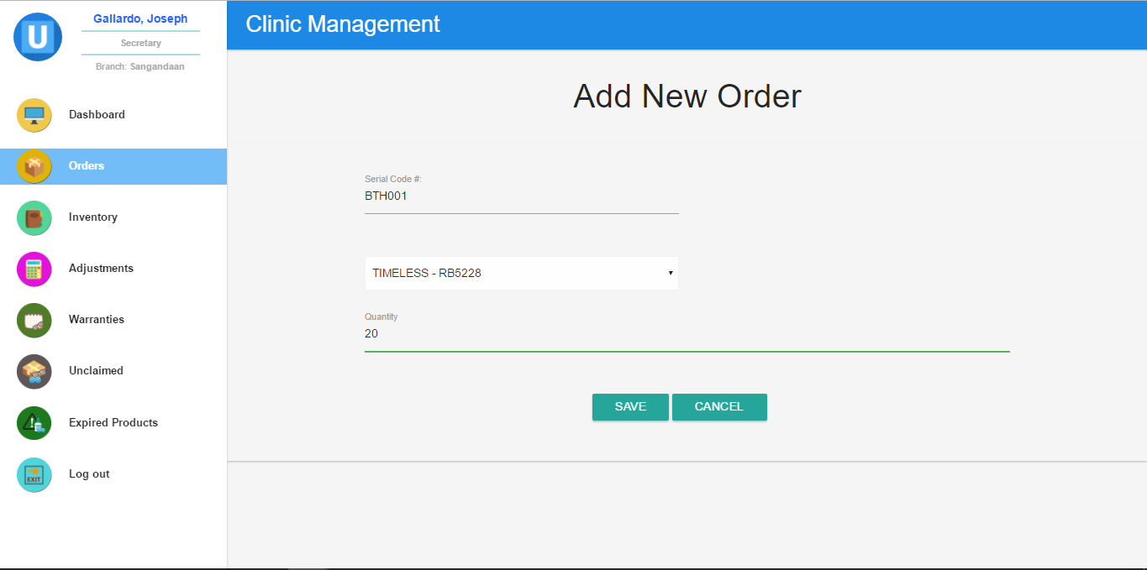

**Figure 2.8 Secretary – Add New Order**

**(**Form used by the secretary to order new product stock.)

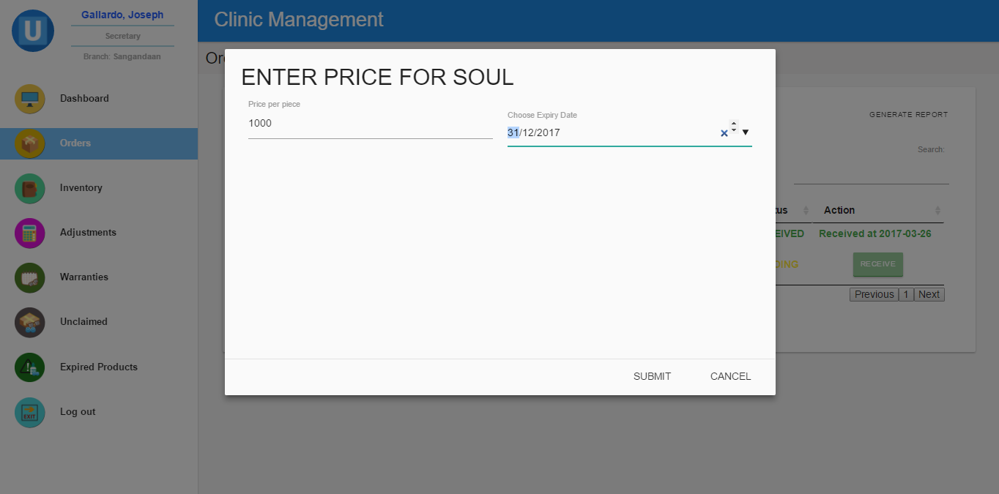

**Figure 2.9 Secretary – Adding Price**

**(**Form where secretary input the price of the product after receiving the orders. Date picker will appear if the product receive is expirable.)

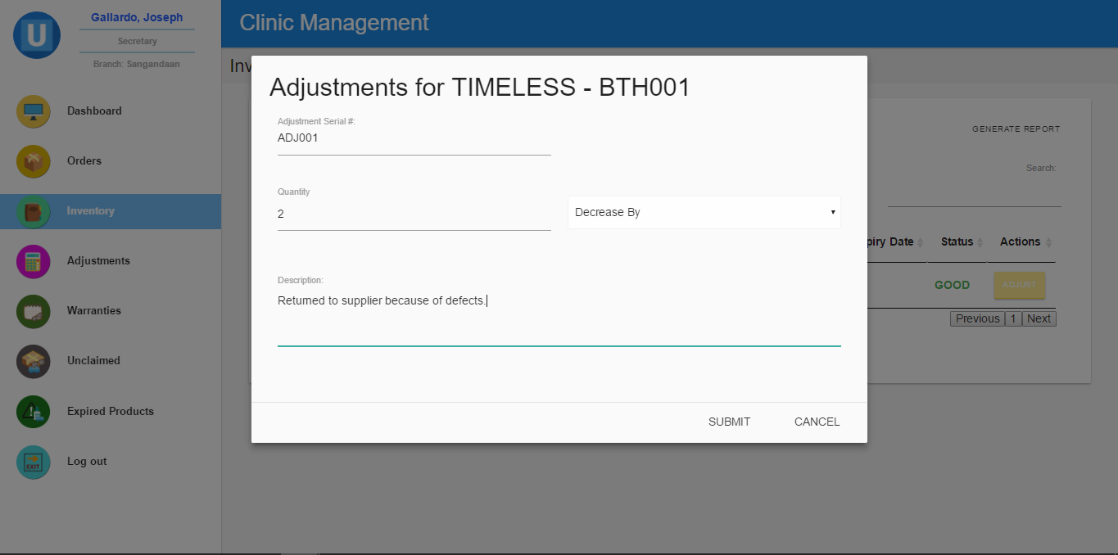

**Figure 2.10 Secretary – Adjustment Form**

**(**Form filled up by the secretary to correct/adjust the inventory status)

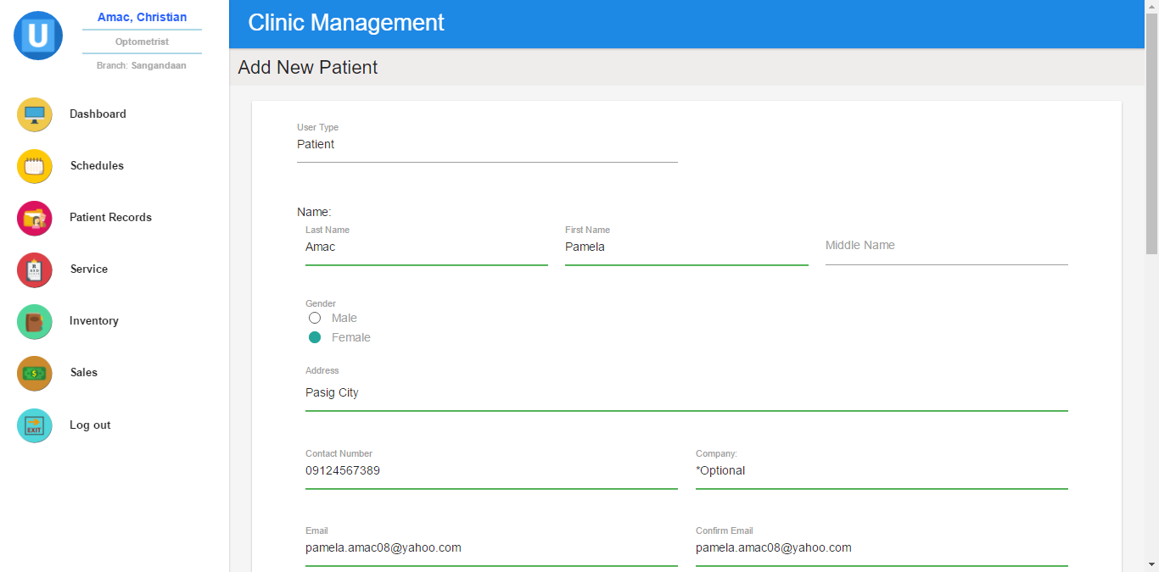

**Figure 2.11.1 Optometrist – Add New Patient Form**

**(**Used by the optometrist for adding record of new patient.)

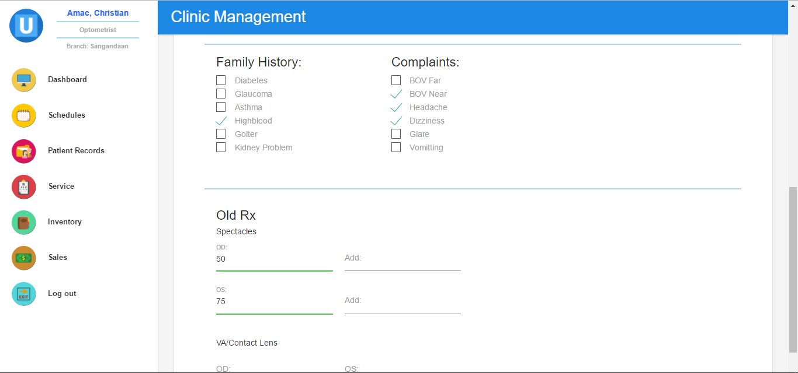

**Figure 2.11.2 Optometrist – Add New Patient Form**

**(**Continuation of add new patient form.)

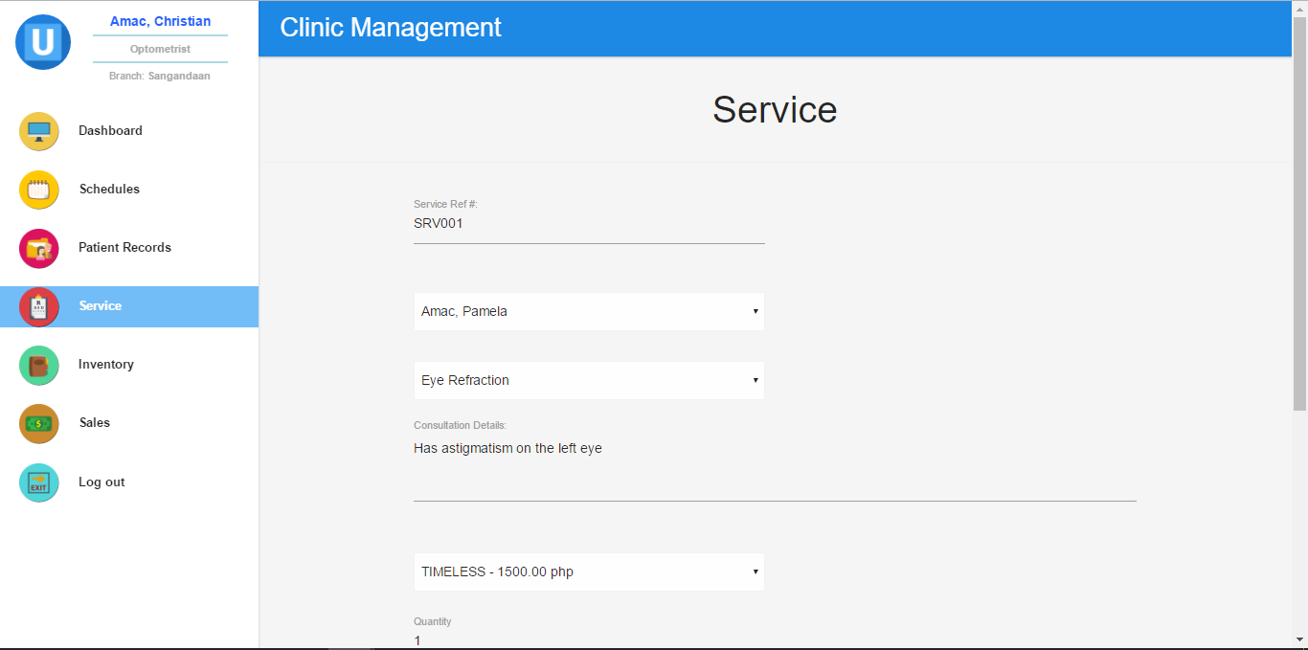

**Figure 2.12.1 Optometrist – Service Form**

**(**Form filled up by the optometrist after the check-up. It contains the consultation details, product bought and the payment terms.)

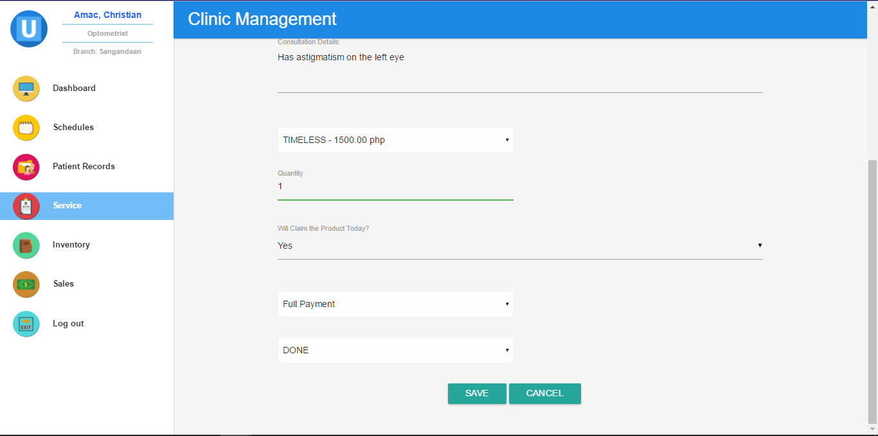

**Figure 2.12.2. Optometrist – Service Form**

**(**Continuation of the service form)

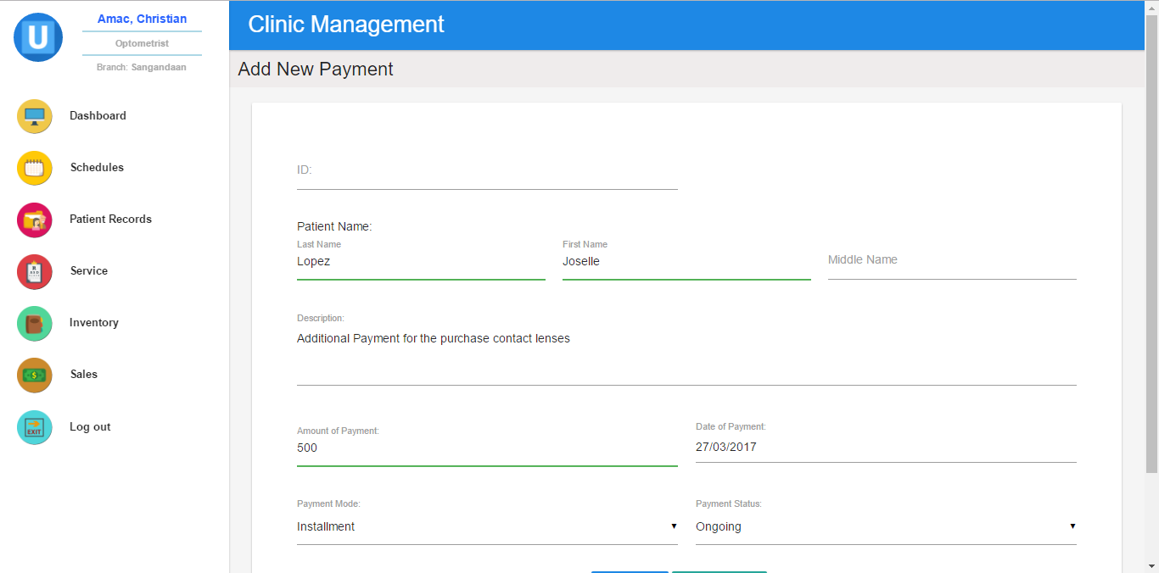

**Figure 2.13 Optometrist – Add New Payment**

**(**Form used by the optometrist for payment receive from patient.)

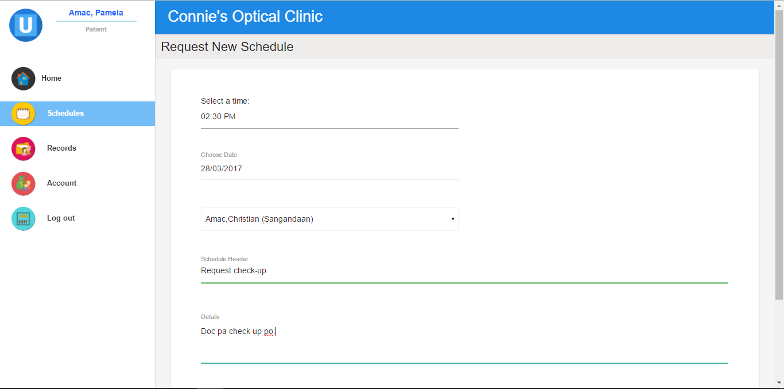

**Figure 2.14 Patient – Request New Schedule Form**

**(**Form for requesting an appointment to the optometrist)